WEEK 7- REACTJS HOL _________________________________________________

- ReatJS-HOL

Create a React Application named “cricketapp” .
1.ListofPlayers
•Declared an array with 11 players and store details of their names and scores using the map feature of ES6.

ListofPlayers.js
import React from 'react';
function ListofPlayers({ players }) {
return (
<ul>
{players.map((item, index) => (
<li key={index}>Mr. {item.name} <span>{item.score}</span></li>
))}
</ul>
);
}
export default ListofPlayers;

•Filtered the players with scores below 70 using arrow functions of ES6.

ScoreBelow70.js
import React from 'react';
function ScoreBelow70({ players }) {
const filtered = players.filter(item => item.score <= 70);
return (
<ul>
{filtered.map((item, index) => (
<li key={index}>Mr. {item.name} <span>{item.score}</span></li>
))}
</ul>
);
}
export default ScoreBelow70;

2.IndianPlayers
a.Displayed the Odd Team Player and Even Team players using the Destructuring features of ES6.

OddPlayers.js
import React from 'react';
export function OddPlayers([first,, third,, fifth]) {
return (
<ul>
<li>First: {first}</li>
<li>Third: {third}</li>
<li>Fifth: {fifth}</li>
</ul>
);
}

Evenplayers.js
import React from 'react';
export function EvenPlayers([, second,, fourth,, sixth]) {
return (
<ul>
<li>Second: {second}</li>
<li>Fourth: {fourth}</li>
<li>Sixth: {sixth}</li>
</ul>
);
}

b.Declared two arrays T20players and RanjiTrophy players and merge the two arrays and display them using the Merge feature of ES6

App.js
import React from 'react';
import ListofPlayers from './components/ListofPlayers';
import ScoreBelow70 from './components/ScoreBelow70';
import { OddPlayers } from './components/OddPlayers';
import { EvenPlayers } from './components/EvenPlayers';
import ListofIndianPlayers from './components/IndianPlayers';
function App() {
const flag = true;
const players = [
{ name: 'Jack', score: 50 },
{ name: 'Michael', score: 70 },
{ name: 'John', score: 40 },
{ name: 'Ann', score: 61 },
{ name: 'Elisabeth', score: 61 },
{ name: 'Sachin', score: 95 },
{ name: 'Dhoni', score: 100 },
{ name: 'Virat', score: 84 },
{ name: 'Jadeja', score: 64 },
{ name: 'Raina', score: 75 },
{ name: 'Rohit', score: 80 }
];
const IndianTeam = ['Sachin1', 'Dhoni2', 'Virat3', 'Rohit4', 'Yuvraj5', 'Raina6'];
const T20Players = ['First Player', 'Second Player', 'Third Player'];
const RanjiTrophyPlayers = ['Fourth Player', 'Fifth Player', 'Sixth Player'];
const IndianPlayers = [...T20Players, ...RanjiTrophyPlayers];
if (flag === true) {
return (
<div>
<h1>List of Players</h1>
<ListofPlayers players={players} />
<hr />
<h1>List of Players having Scores Less than 70</h1>
<ScoreBelow70 players={players} />
</div>
);
} else {
return (
<div>
<h1>Indian Team</h1>
<h2>Odd Players</h2>
{
OddPlayers(IndianTeam)
}
<hr />
<h2>Even Players</h2>
{
EvenPlayers(IndianTeam)
}
<hr />
<h1>List of Indian Players Merged:</h1>
<ListofIndianPlayers IndianPlayers={IndianPlayers}/>
</div>
);
}
}
export default App;

OUTPUT:

When Flag=true

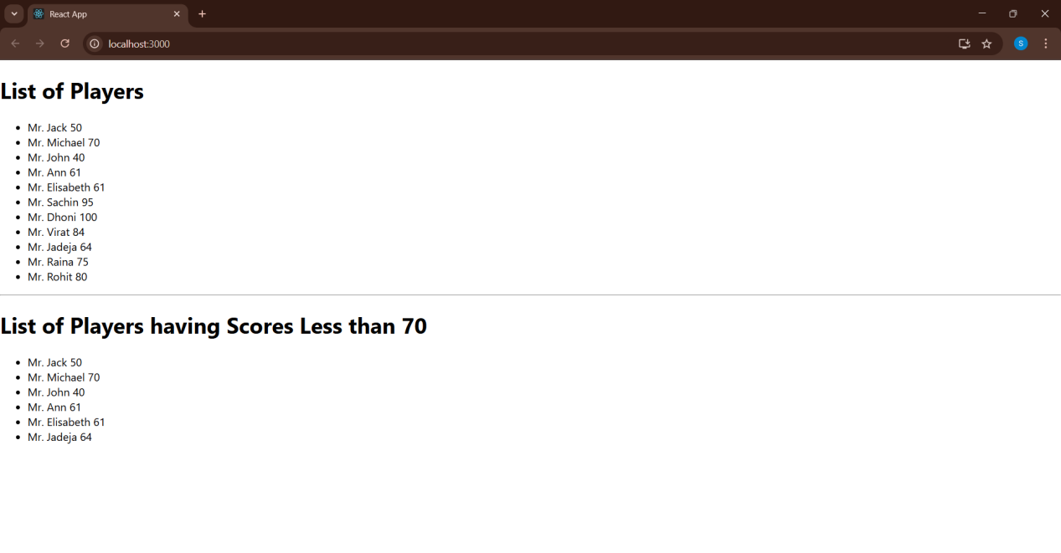

When Flag=false
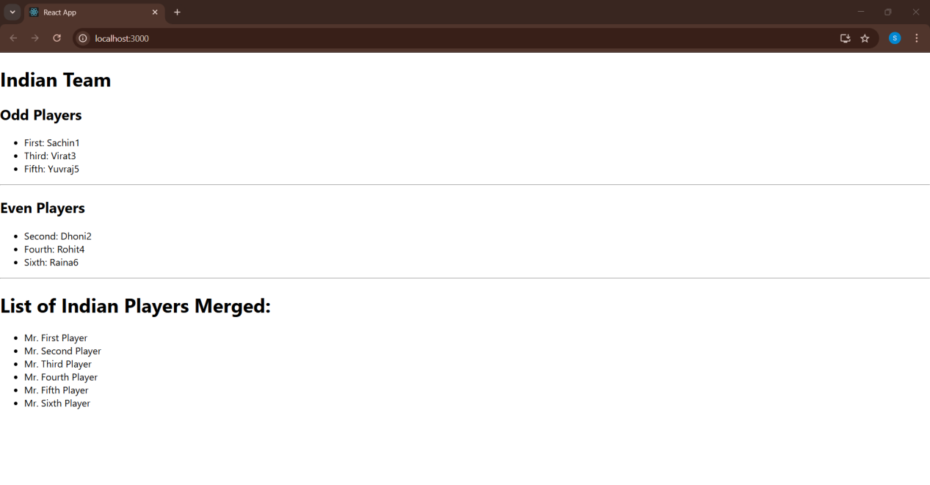

Terminal:

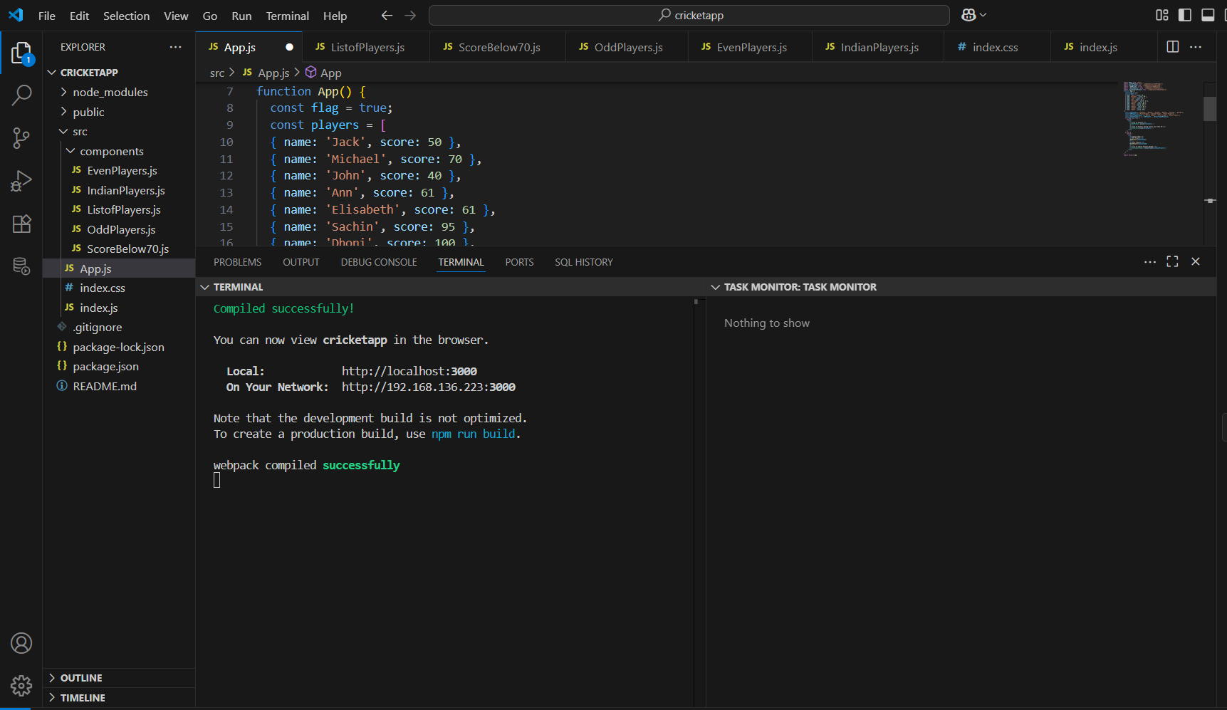

10.ReatJS-HOL

Create a React Application named “officespacerentalapp”.

App.js
import React from 'react';
import './OfficeStyles.css';
import officeImage from './office.jpg';
function App() {
const element = "Office Space";
const jsxatt = <img src={officeImage} width="25%" height="25%" alt="Office Space" />;
const officeList = [
{ Name: "DBS", Rent: 50000, Address: "Chennai" },
{ Name: "WeWork", Rent: 75000, Address: "Bangalore" },
{ Name: "Regus", Rent: 62000, Address: "Mumbai" },
{ Name: "Innov8", Rent: 55000, Address: "Hyderabad" }
];
return (
<div className="container">
<h1>{element}, at Affordable Range</h1>
{jsxatt}

<h2>Available Office Spaces:</h2>
{officeList.map((item, index) => {
let colors = [];
if (item.Rent <= 60000) {
colors.push("textRed");
} else {
colors.push("textGreen");
}
return (
<div key={index}>
<h3>Name: {item.Name}</h3>
<h3 className={colors.join(" ")}>Rent: Rs. {item.Rent}</h3>
<h3>Address: {item.Address}</h3>
<hr />
</div>
);
})}
</div>
);
}
export default App;

OUTPUT:

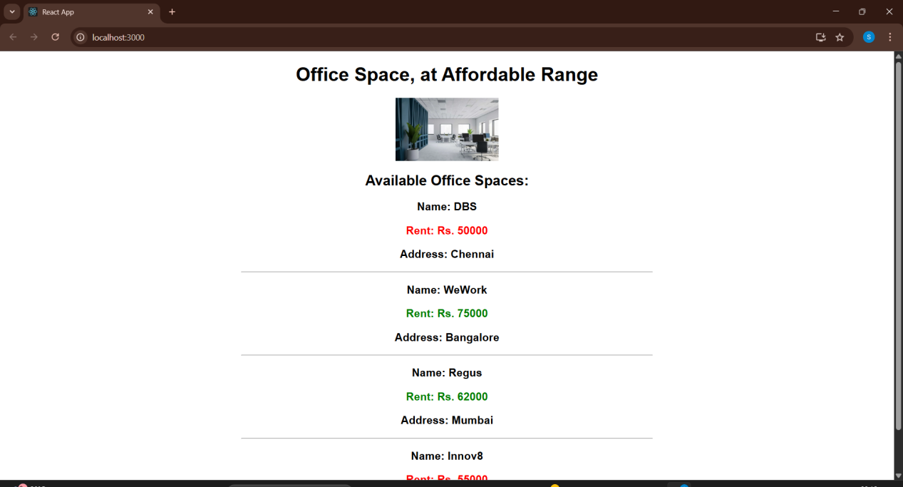

Terminal:

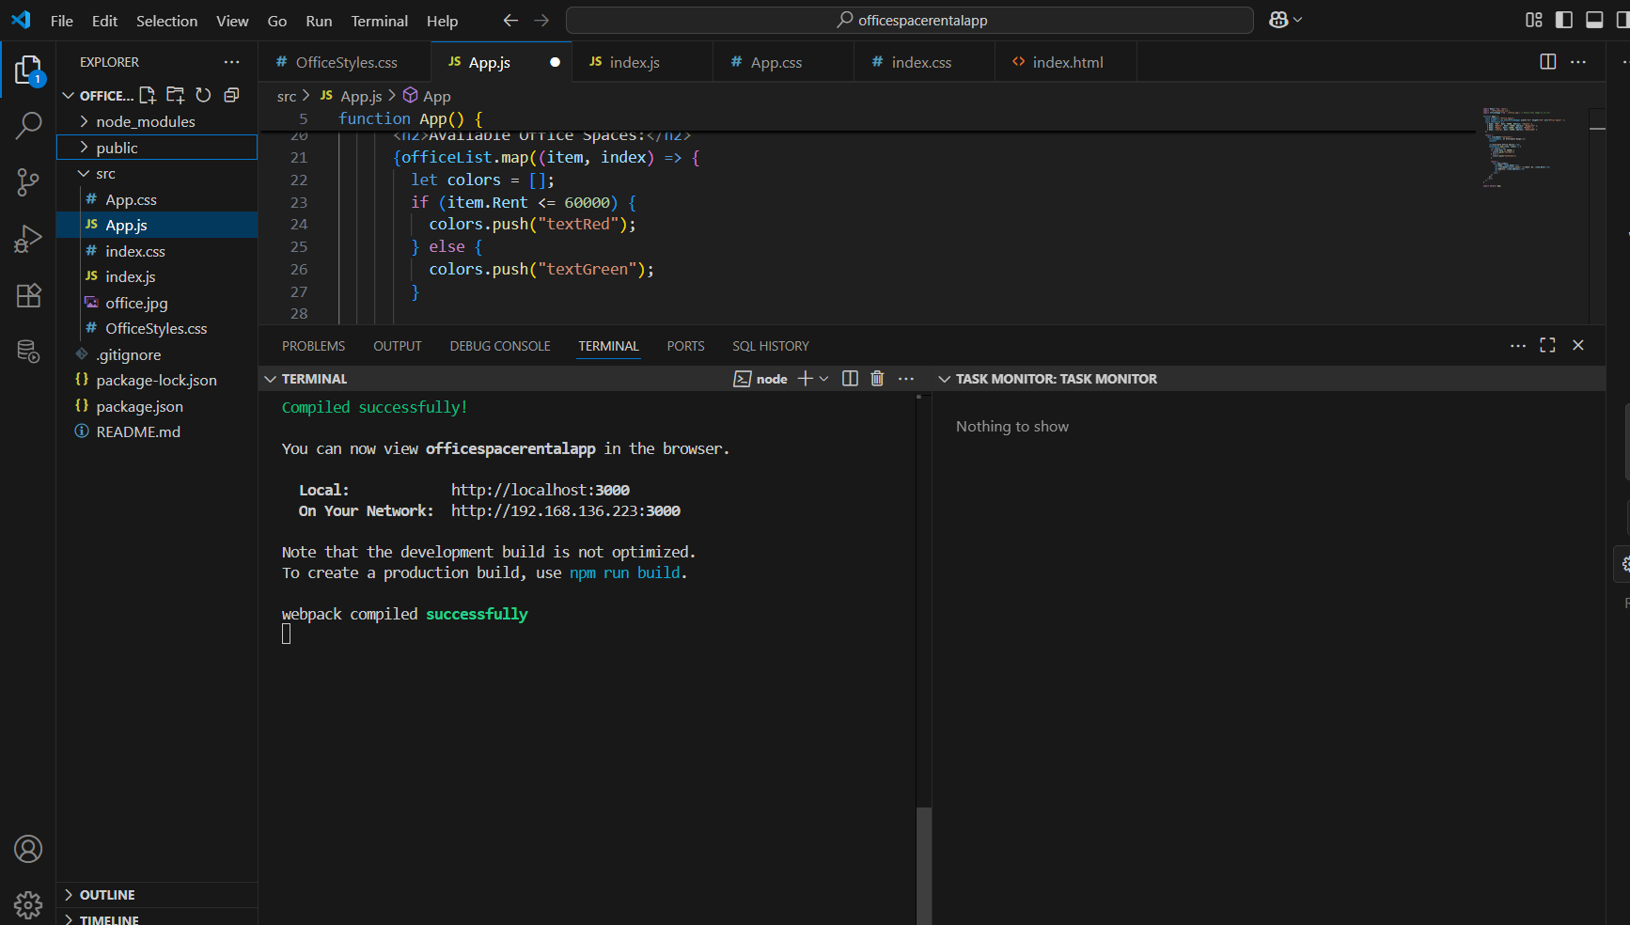
11.ReatJS-HOL

Create a React Application “eventexamplesapp” to handle various events of the form elements in HTML.

- Created “Increment” button to increase the value of the counter and “Decrement” button to decrease the value of the counter.

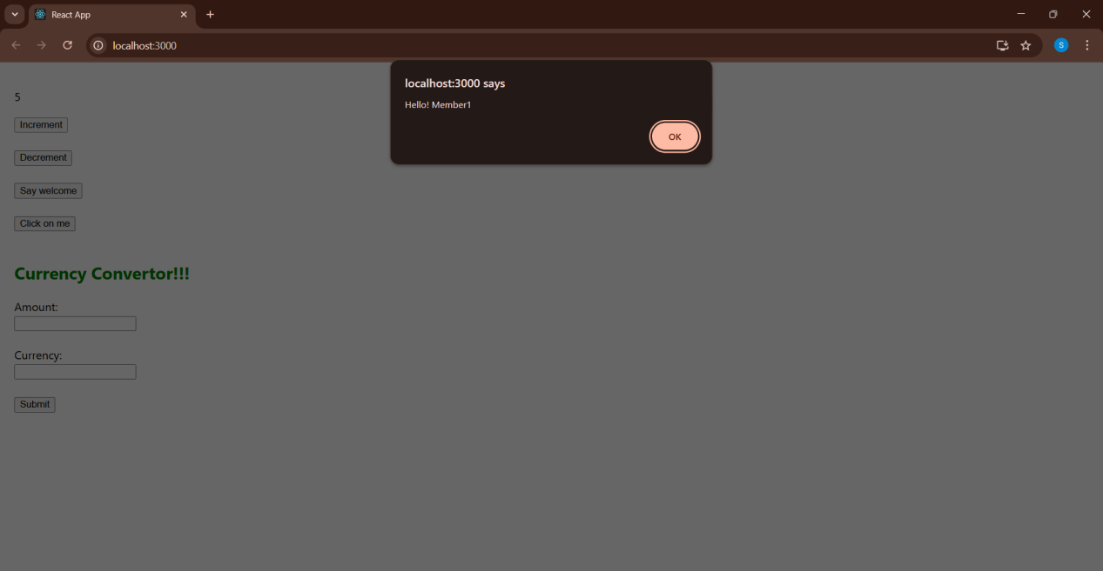

- Created a button “Say Welcome” which invokes the function which takes “welcome” as an argument.

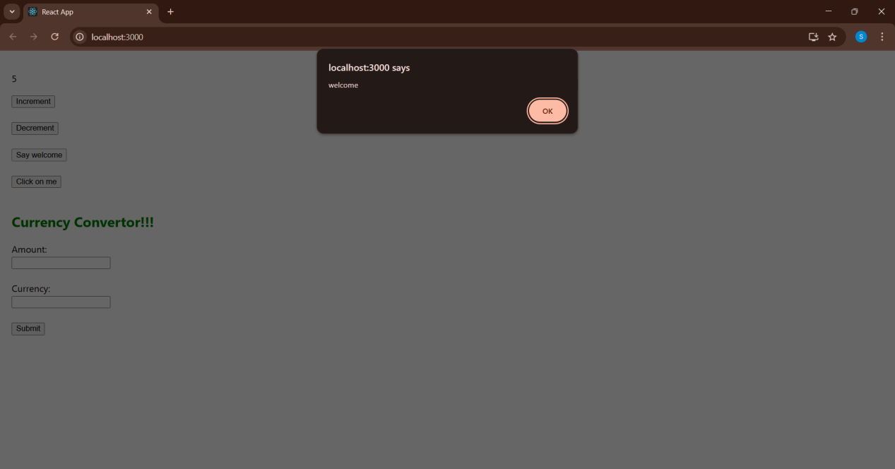

- Created a button which invokes synthetic event “OnPress” which display “I was clicked”.

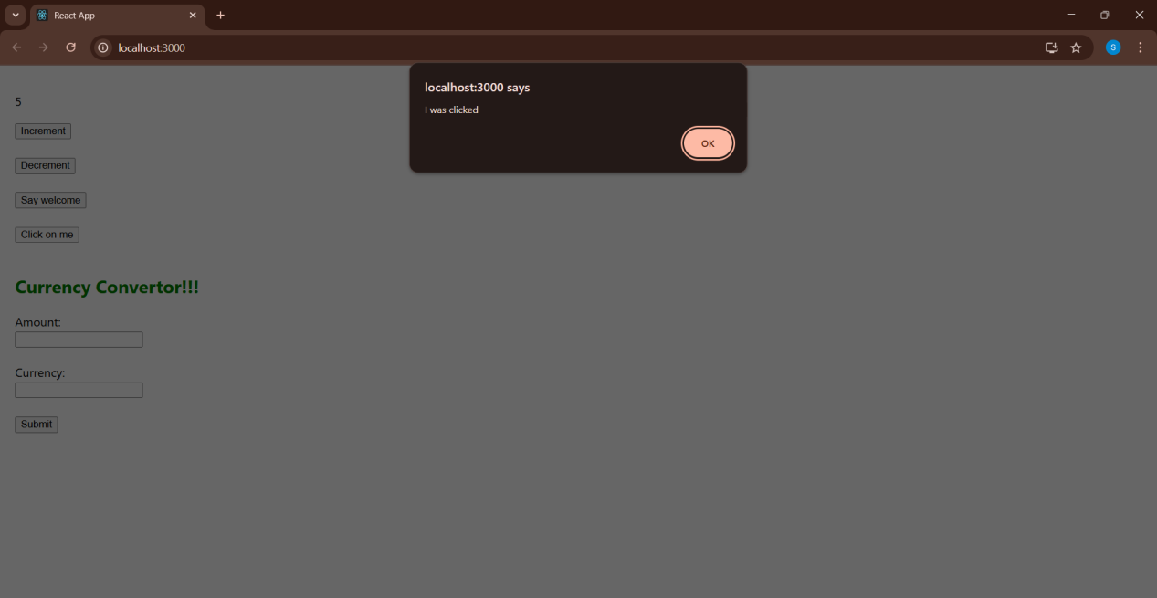

Created a “CurrencyConvertor” component which will convert the Indian Rupees to Euro when the Convert button is clicked.

CurrencyConvertor.js
import React, { useState } from 'react';
function CurrencyConvertor() {
const [amount, setAmount] = useState('');
const [currency, setCurrency] = useState('');
const handleSubmit = () => {
const amt = parseFloat(amount);
if (currency.toLowerCase() === 'euro') {
const rupees = amt * 81;
alert(`Converting to Euro Amount is ${rupees}`);
} else {
alert("Please enter 'Euro' as currency to convert");}
};
return (
<div>
<label>Amount:</label><br />
<input
type="text"
value={amount}
onChange={(e) => setAmount(e.target.value)}
/><br /><br />
<label>Currency:</label><br />
<input
type="text"
value={currency}
onChange={(e) => setCurrency(e.target.value)}
/><br /><br />
<button onClick={handleSubmit}>Submit</button>
</div>
);
}
export default CurrencyConvertor;

App.js
import React, { useState } from 'react';
import CurrencyConvertor from './CurrencyConvertor';
function App() {
const [count, setCount] = useState(0);
const increment = () => {
setCount(count + 1);
sayHello();
};
const decrement = () => {
setCount(count - 1);
};
const sayHello = () => {
alert("Hello! Member1");
};
const sayWelcome = (msg) => {
alert(msg);
};
const handleClick = () => {
alert("I was clicked");
};
return (
<div style={{ padding: '20px' }}>
<p>5</p>
<button onClick={increment}>Increment</button> <br /><br />
<button onClick={decrement}>Decrement</button> <br /><br />
<button onClick={() => sayWelcome("welcome")}>Say welcome</button> <br /><br />
<button onClick={handleClick}>Click on me</button> <br /><br />
<h2 style={{ color: 'green' }}>Currency Convertor!!!</h2>
<CurrencyConvertor />
</div>
);
}
export default App;

OUTPUT:

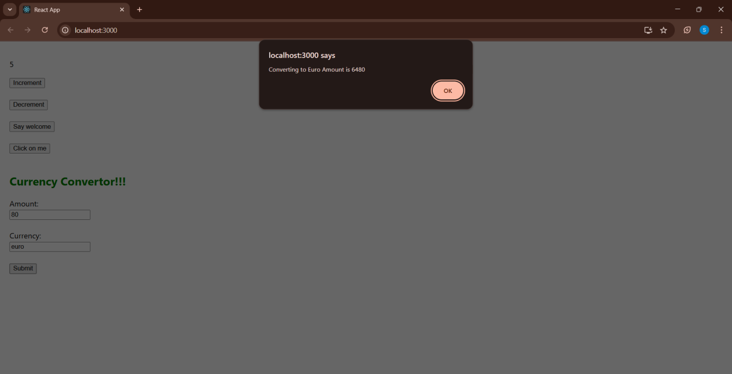

Terminal:

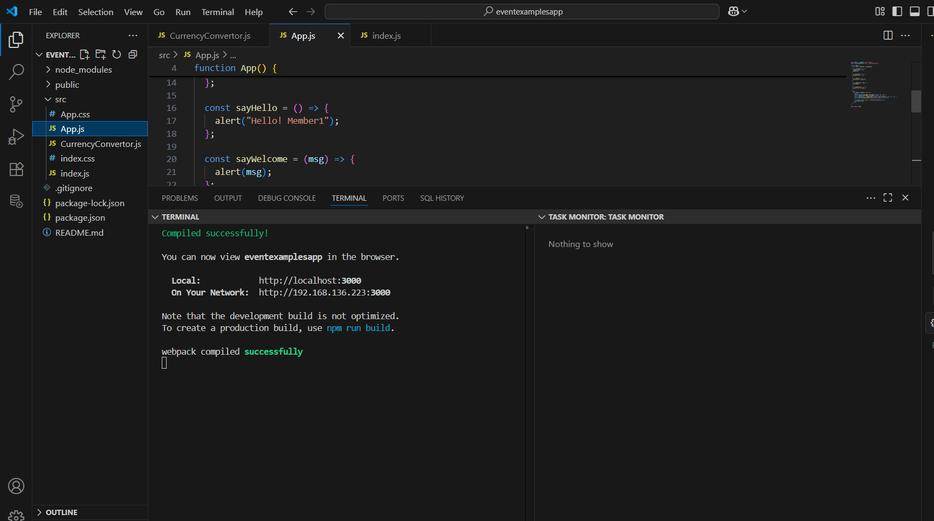

12.ReatJS-HOL

Create a React Application named “ticketbookingapp” where the guest user can browse the page where the flight details are displayed whereas the logged in user only can book tickets.
The Login and Logout buttons should accordingly display different pages. Once the user is logged in the User page should be displayed. When the user clicks on Logout, the Guest page should be displayed.
Code:
App.js
import React, { useState } from 'react';
function LoginButton(props) {
return <button onClick={props.onClick}>Login</button>;
}

function LogoutButton(props) {
return <button onClick={props.onClick}>Logout</button>;
}

function UserGreeting() {
return <h1>Welcome back</h1>;
}
function GuestGreeting() {
return <h1>Please sign up.</h1>;
}

function Greeting(props) {
if (props.isLoggedIn) {
return <UserGreeting />;
}
return <GuestGreeting />;
}

function FlightList() {
const flights = [
{ id: 1, from: 'Hyderabad', to: 'Bangalore', time: '9:45 AM' },
{ id: 2, from: 'Vijayawada', to: 'Chennai', time: '12:30 PM' },
{ id: 3, from: 'Vizag', to: 'Delhi', time: '7:15PM' },
];
return (
<div>
<h3>Available Flights</h3>
<ul style={{ listStyle: 'none', padding: 0 }}>
{flights.map((flight) => (
<li key={flight.id}>
{flight.from} → {flight.to} at {flight.time}
</li>
))}
</ul>
</div>
);
}

function BookingForm() {
return (
<div>
<h3>Book Your Ticket</h3>
<form>
<label>
Flight ID: <input type="text" placeholder="Enter Flight ID" />
</label>
<br />
<label>
Name: <input type="text" placeholder="Enter Your Name" />
</label>
<br />
<button type="submit">Book Ticket</button>
</form>
</div>
);
}

function App() {
const [isLoggedIn, setIsLoggedIn] = useState(false);
let button = isLoggedIn ? (
<LogoutButton onClick={() => setIsLoggedIn(false)} />
) : (
<LoginButton onClick={() => setIsLoggedIn(true)} />
);

return (
<div
style={{
textAlign: 'center',
padding: '40px',
fontFamily: 'Arial',
backgroundColor: '#f5f5f5',
minHeight: '100vh',
}}
>
<h1 style={{ color: '#333' }}>Ticket Booking App</h1>
<Greeting isLoggedIn={isLoggedIn} />
{isLoggedIn ? <BookingForm /> : <FlightList />}
<div style={{ marginTop: '20px' }}>{button}</div>
</div>
);
}
export default App;

OUTPUT:

This is the page where guest user can see the flight details without log in.

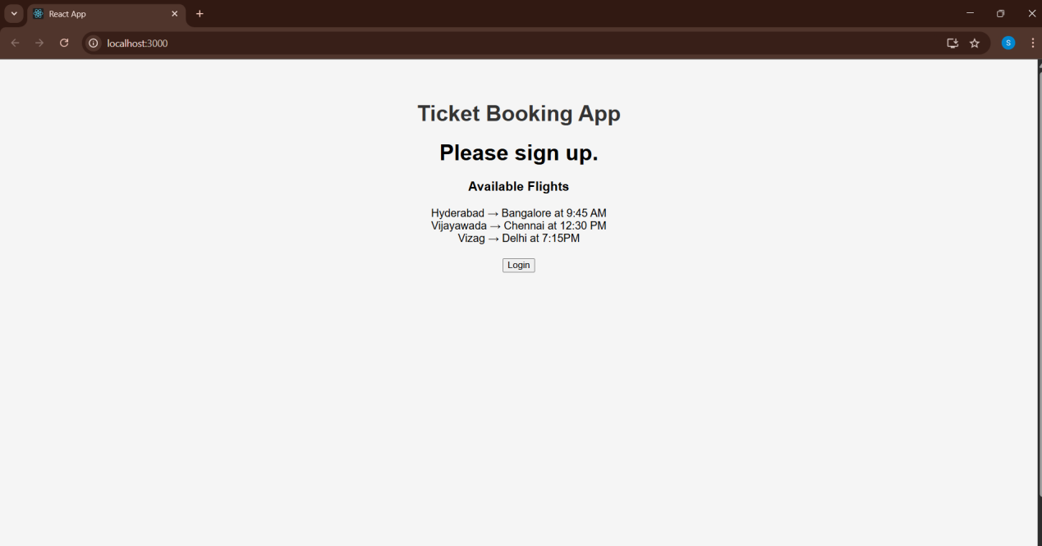

This is the page where logged in user can book tickets.

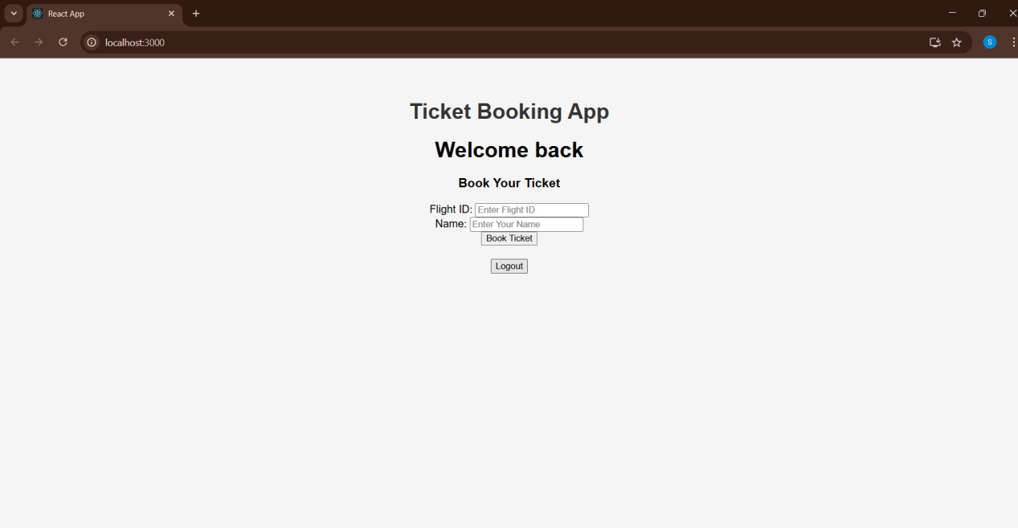

Terminal:

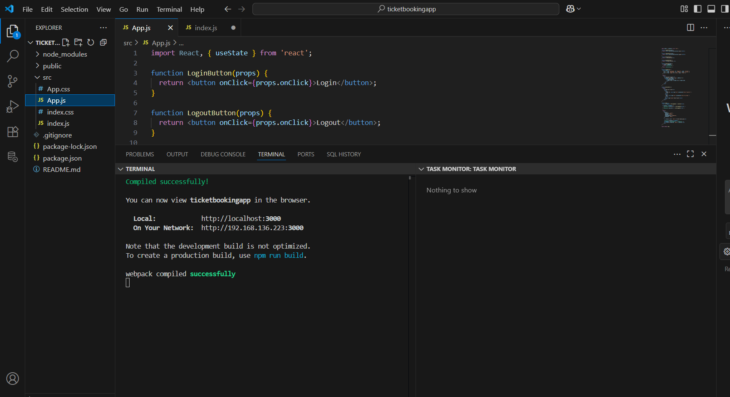

13.ReatJS-HOL

Create a React App named “bloggerapp” .
Code:

BookDetails.js
import React from 'react';
function BookDetails(props) {
if (!props.show) return null;
const bookdet = (
<ul>
{props.books.length === 0 ? (
<li>No books found.</li>
) : (
props.books.map((book) => (
<div key={book.id}>
<h3>{book.bname}</h3>
<h4>{book.price}</h4>
</div>
))
)}
</ul>
);
return (
<div className="section">
<h2>Book Details</h2>
{bookdet}
</div>
);
}
export default BookDetails;

BlogDetails.js
import React from 'react';
function BlogDetails({ blogs, show }) {
return (
show && ( // Type 4
<div className="section">
<h2>Blog Details</h2>
{
(() => { // Type 6
if (blogs.length === 0) {
return <p>No blog posts found.</p>;
} else {
return blogs.map((blog, i) => (
<div key={i}>
<h3>{blog.title}</h3>
<p><strong>{blog.author}</strong></p>
<p>{blog.content}</p>
</div>
));
}
})()
}
</div>
)
);
}
export default BlogDetails;

CourseDetails.js
import React from 'react';
function CourseDetails({ courses, show }) {
if (!show) return null; // Type 2
let content = <p>No courses available</p>; // Type 5
if (courses.length > 0) { // Type 1
content = courses.map((course, index) => (
<div key={index}>
<h3>{course.name}</h3>
<p>{course.date}</p>
</div>
));
}
return (
<div className="section">
<h2>Course Details</h2>
{content}
</div>
);
}

export default CourseDetails;

App.js
import React from 'react';
import BookDetails from './BookDetails';
import BlogDetails from './BlogDetails';
import CourseDetails from './CourseDetails';
import './App.css';
function App() {
const books = [
{ id: 1, bname: 'Master React', price: 670 },
{ id: 2, bname: 'Deep Dive into Angular 11', price: 800 },
{ id: 3, bname: 'Mongo Essentials', price: 450 },
];
const blogs = [
{ title: 'React Learning', author: 'Stephen Biz', content: 'Welcome to learning React!' },
{ title: 'Installation', author: 'Schwazdenier', content: 'You can install React from npm.' },
];
const courses = [
{ name: 'Angular', date: '4/5/2021' },
{ name: 'React', date: '6/3/2021' },
];
return (
<div>
<h1 className="main-heading">Blogger App</h1>
<div className="container">
<CourseDetails courses={courses} show={true} />
<BookDetails books={books} show={true} />
<BlogDetails blogs={blogs} show={true} />
</div>
</div>
);
}
export default App;

OUTPUT:

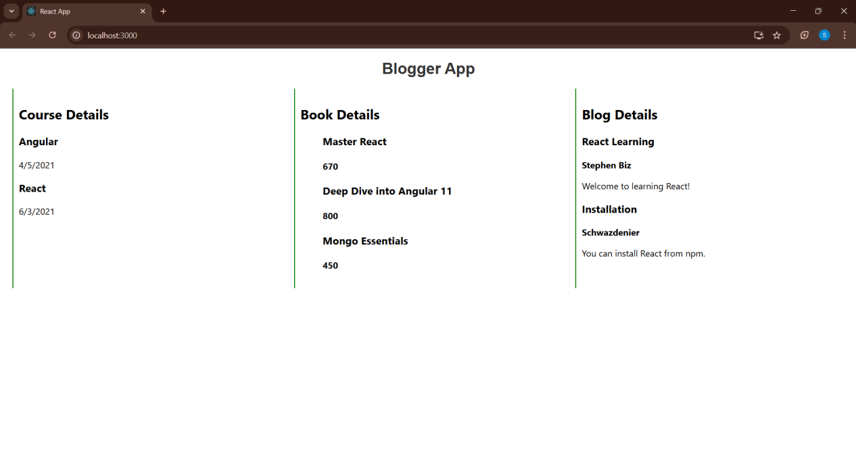

Terminal:

